

JAMES MARKS ACADEMY

FIRST AID POLICY

This is a STATUTORY POLICY and must be published on the Academy website.

This policy was revised in September 2025 and will be reviewed no less than annually.

It was ratified by the Trust Board on 01st December 2025

This policy applies to the James Marks Academy, which is part of the James Marks Academy Trust.

Aims
The aims of our first aid policy are to:
- Ensure the health and safety of all staff, pupils and visitors
- Ensure that staff and governors are aware of their responsibilities with regards to health and safety
- Provide a framework for responding to an incident and recording and reporting the outcomes

Legislation and guidance
This policy is based on advice from the Department for Education (DfE) on first aid in schools and health and safety in schools, and guidance from the Health and Safety Executive (HSE) on incident reporting in schools, and the following legislation:
- The Health and Safety (First-Aid) Regulations 1981, which state that employers must provide adequate and appropriate equipment and facilities to enable first aid to be administered to employees, and qualified first aid personnel
- The Management of Health and Safety at Work Regulations 1992, which require employers to make an assessment of the risks to the health and safety of their employees
- The Management of Health and Safety at Work Regulations 1999, which require employers to carry out risk assessments, make arrangements to implement necessary measures, and arrange for appropriate information and training
- The Reporting of Injuries, Diseases and Dangerous Occurrences Regulations (RIDDOR) 2013, which state that some accidents must be reported to the Health and Safety Executive (HSE), and set out the timeframe for this and how long records of such accidents must be kept
- The Social Security (Claims and Payments) Regulations 1979, which set out rules on the retention of accident records
- The Education (Independent School Standards) Regulations 2014, which require that suitable space is provided to cater for the medical and therapy needs of pupils
This policy complies with our funding agreement and articles of association.

Roles and responsibilities

Appointed person(s) and first aiders
Employers must have a sufficient number of suitably trained first aiders to care for employees in case they are injured at work. However, the minimum legal requirement is to have an ‘appointed person’ to take charge of first aid arrangements, provided your assessment of need has taken into account the nature of employees' work, the number of staff, and the layout and location of the school. The appointed person does not need to be a trained first aider.

The school’s appointed persons are Mandy Crow and Lara Rowe.
They are responsible for:
- Taking charge when someone is injured or becomes ill
- Making sure there is an adequate supply of medical materials in first aid kits, and replenishing the contents of these kits
- Making sure that an ambulance or other professional medical help is summoned when appropriate
- First aiders are trained and qualified to carry out the role (see section 7) and are responsible for:
- Acting as first responders to any incidents; they will assess the situation where there is an injured or ill person, and provide immediate and appropriate treatment
- Sending pupils home to recover, where necessary
- Filling in an accident report on the same day as, or as soon as is reasonably practicable, after an incident
- Keeping their contact details up to date

James Marks Academy appointed persons and/or first aiders are listed in Appendix A. Their names will be displayed prominently around the school.

The Board of Trustees
The Board of Trustees has ultimate responsibility for health and safety matters in the school, but delegates
Operational matters and day-to-day tasks to the head teacher and staff members.

The Head Teacher
The Head Teacher is responsible for the implementation of this policy, including:
- Making sure that an appropriate number of staff are present in the school at all times
- Making sure that first aiders have an appropriate qualification, keep training up-to-date and remain competent to perform their role
- Making sure all staff are aware of first aid procedures
- Making sure appropriate risk assessments are completed and appropriate measures are put in place
- Undertaking, or making sure that managers undertake, risk assessments, as appropriate, and that appropriate measures are put in place
- Making sure that adequate space is available for catering to the medical needs of pupils
- Reporting specified incidents to the HSE when necessary (see section 6)

Staff
School staff are responsible for:
- Making sure they follow first aid procedures
- Making sure they know who the appointed persons in school are
- Informing the Head Teacher or their manager of any specific health conditions or first aid needs

First aid procedures

In-school procedures
Due to the nature of the school and the pupils’ levels of need. Any injury or accident is reported to the main office. In the event of an accident resulting in injury:
- The closest member of staff present will assess the seriousness of the injury and seek the assistance of a qualified first aider, if appropriate, who will provide the required first aid treatment
- The first aider, if called, will assess the injury and decide if further assistance is needed from a colleague or the emergency services. They will remain on the scene until help arrives
- The first aider will also decide whether the injured person should be moved or placed in a recovery position
- If the first aider judges that a pupil is too unwell to remain in school, the person on-call will contact parents/carers and ask them to collect their child.
- If emergency services are called, a senior member of staff will contact parents/carers immediately
- The appointed person will complete an accident report form on the same day or as soon as is reasonably practicable after an incident resulting in an injury

Off-site procedures
When taking pupils off the school premises, staff will make sure that they always have the following:
- A mobile phone
- A portable first aid kit including, at minimum:
  - A leaflet giving general advice on first aid
  - 6 individually wrapped sterile adhesive dressings
  - 1 large sterile unmedicated dressing
  - 2 triangular bandages – individually wrapped and preferably sterile
  - 2 safety pins
  - Individually wrapped moist cleansing wipes
  - 2 pairs of disposable gloves
- Information about the specific medical needs of pupils
- Parents/carers’ contact details

When transporting pupils using a minibus, the school will make sure the vehicle is equipped with a clearly marked first aid box containing, at minimum:
- 10 antiseptic wipes, foil packed
- 1 conforming disposable bandage (not less than 7.5cm wide)
- 2 triangular bandages
- 1 packet of 24 assorted adhesive dressings
- 3 large sterile unmedicated ambulance dressings (not less than 15cm × 20 cm)
- 2 sterile eye pads, with attachments
- 12 assorted safety pins
- 1 pair of rustproof blunt-ended scissors

Risk assessments will be completed by the Offsite Co-Ordinator prior to any educational visit that necessitates taking pupils off school premises.

First aid equipment
The academy provides all first aiders with a first aid kit to maintain and have readily accessible. All staff are aware of where the main first aid room is and how to access medical supplies.

A travel first aid kit is kept in the school vehicles for use on trips/events. First aid kits should contain a sufficient quantity of suitable first aid materials and nothing else. See appendix B for a suggested list of minimum contents.

All first aid kits must be checked regularly and restocked by the designated member of staff, items should not be used after expiry date shown on packaging. Extra stock should be kept in the first aid room.

First aid does not include the administration of medicines and thus first aid boxes should NOT contain drugs of any kind including paracetamol, antiseptic creams etc.

First aid arrangements must also be in place where premises are used outside of ‘normal’ hours, e.g. for letting. Arrangements must be in place to ensure a first aid kit / telephone is available to persons who may require its use.

Where mains tap water is not readily available for eye irrigation, sterile water or sterile normal saline
(0.9%) in sealed disposable containers should be provided. Each container should hold at least 300ml and should not be re-used once the sterile seal is broken. At least 900ml should be provided. Eye baths/eye cups/refillable containers should not be used for eye irrigation.

Record-keeping and reporting

First aid and accident record book
- An accident form will be completed by the first aider on the same day or as soon as possible after an incident resulting in an injury
- As much detail as possible will be supplied when reporting an accident, including all of the information included in the accident form contained within the accident book
- For accidents involving pupils, a copy of the accident report form will also be added to the pupil’s educational record
- Records held in the accident book will be retained by the school for a minimum of 3 years, in accordance with regulation 25 of the Social Security (Claims and Payments) Regulations 1979, and then securely disposed of

Reporting to the HSE
The Office Manager will keep a record of any accident that results in a reportable injury, disease, or dangerous occurrence as defined in the RIDDOR 2013 legislation (regulations 4, 5, 6 and 7).
The Chief Financial Officer (CFO) will report these to the HSE as soon as is reasonably practicable and in any event within 10 days of the incident – except where indicated below. Fatal and major injuries and dangerous occurrences will be reported without delay (i.e. by telephone) and followed up in writing within 10 days.

School staff: reportable injuries, diseases or dangerous occurrences
These include:
- Death
- Specified injuries, which are:
  - Fractures, other than to fingers, thumbs and toes
  - Amputations
- Any injury likely to lead to permanent loss of sight or reduction in sight
- Any crush injury to the head or torso causing damage to the brain or internal organs
- Serious burns (including scalding) which:
  - Covers more than 10% of the whole body’s total surface area; or
  - Causes significant damage to the eyes, respiratory system or other vital organs
- Any scalping requiring hospital treatment
- Any loss of consciousness caused by head injury or asphyxia
- Any other injury arising from working in an enclosed space which leads to hypothermia or heat-induced illness, or requires resuscitation or admittance to hospital for more than 24 hours
- Work-related injuries that lead to an employee being away from work or unable to perform their normal work duties for more than 7 consecutive days (not including the day of the incident). In this case, the CFO will report these to the HSE as soon as reasonably practicable and in any event within 15 days of the accident
- Occupational diseases where a doctor has made a written diagnosis that the disease is linked to occupational exposure. These include:
  - Carpal tunnel syndrome
  - Severe cramp of the hand or forearm
  - Occupational dermatitis, e.g. from exposure to strong acids or alkalis, including domestic bleach
  - Hand-arm vibration syndrome
  - Occupational asthma, e.g. from wood dust
  - Tendonitis or tenosynovitis of the hand or forearm
  - Any occupational cancer
  - Any disease attributed to an occupational exposure to a biological agent
- Near-miss events that do not result in an injury, but could have done. Examples of near-miss events relevant to schools include, but are not limited to:
  - The collapse or failure of load-bearing parts of lifts and lifting equipment
  - The accidental release of a biological agent likely to cause severe human illness
  - The accidental release or escape of any substance that may cause a serious injury or damage to health
  - An electrical short circuit or overload causing a fire or explosion

Pupils and other people who are not at work (e.g. visitors): reportable injuries, diseases or dangerous occurrences
These include:
- Death of a person that arose from, or was in connection with, a work activity*
- An injury that arose from, or was in connection with, a work activity* and where the person is taken directly from the scene of the accident to hospital for treatment
*An accident “arises out of” or is “connected with a work activity” if it was caused by:
  - A failure in the way a work activity was organised (e.g. inadequate supervision of a field trip)
  - The way equipment or substances were used (e.g. lifts, machinery, experiments etc); and/or
  - The condition of the premises (e.g. poorly maintained or slippery floors)

- Information on how to make a RIDDOR report is available here:
- How to make a RIDDOR report, HSE
http://www.hse.gov.uk/riddor/report.htm

Notifying parents/carers
The first aider will inform parents of any accident or injury sustained by a pupil, and any first aid treatment given, on the same day, or as soon as reasonably practicable. Parents will also be informed if emergency services are called.

Training
Dependent on the size of the provision and assessment of need, first aiders should hold a valid certificate in either:
- First aid at work (FAW) –a three-day course (18 hours);
- Emergency first aid at work (EFAW) – a one-day course (6 hours).
First aid training is valid for three years, after which a refresher course is required before re-certification. An annual refresher is also available, but this is not mandatory. The provision will ensure that refresher training is undertaken before certificates expire. A record of first aiders and their certification dates should be maintained.

Health professionals with the following training /experience are qualified to administer first aid without need to hold a FAW or EFAW qualification.
- Doctors registered with the General Medical Council;
- Nurses registered with the Nursing and Midwifery Council;
- Paramedics registered with the Health Professions Council.
Staff who administer first aid according to their training and in the course of their employment should
be covered by employer’s liability insurance.

Automated External Defibrillators (AED) are likely to be used very infrequently and are more likely to be used on an adult than a pupil. There are defibrillators onsite and in the H&S policy are a list of community automated external defibrillators.

Some First aid at work courses do not cover the use of defibrillators and it is recommended that specific training is completed before using one.

Monitoring arrangements
This policy will be reviewed by the CFO every year. At every review, the policy will be approved by the Trust Board.

Links with other policies
This first aid policy is linked to the:
- Health and safety policy
- Risk assessment policy
- Supporting pupils with medical conditions

Additional Information
- Department of Health Guidance on the use of emergency salbutamol inhalers in schools.
- Defibrillators in schools
- DFE Statutory Guidance Supporting Pupils with medical conditions at school

Advice on medical issues should be sought from the designated school nurse, the schools local Primary Care Trust (PCT), which includes guidance on communicable diseases, NHS Direct or from the SEN Advisors.

For more information and advice with regards to medicines, you can always contact your local community pharmacist.

Further support can be accessed from:
- GP
- Out of Hours service
- NHS 111
- A&E (if appropriate)

Guidance and Reference Sources
Department of Education
Ofsted
Department of Health
Care Inspectorate
Opus
Scottish Executive

APPENDIX A: FIRST AID ROOM IS ON THE GROUND FLOOR

Lead First Aiders
Mandy Crow  FAW Trained (04/2023 to 04/2026)  Responsible Person for ‘RIDDOR’ |  | Lara Rowe  FAW Trained (04/2024–04/2027)
 |  | 
First Aiders
Leia Mintoff-Turner
EFAW Trained (04/2024 to 04/2027)


APPENDIX B – FIRST AID KITS
As a guide suggested contents lists for first aid kits are as follows:
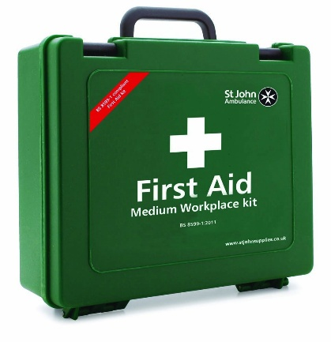 | First aid kit  - Leaflet giving advice on first aid;  - Twenty individually wrapped sterile plasters (assorted sizes) appropriate to the work environment;  - Two sterile eye pads;  - Two individually wrapped triangular bandages;  - Six safety pins;  - Six medium sized individually wrapped sterile unmedicated wound dressings (12x12cm);  - Two large sterile individually wrapped unmedicated wound dressings (18x18cm);  - At least 3 pairs of disposable gloves.
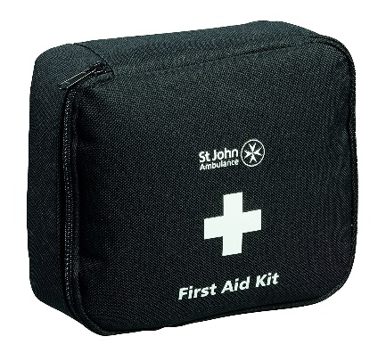 | BS 8599 - Motor Vehicle First Aid Kit (Travel kit)
  P95148K | First Aid in Emergency Booklet – 2014 | x 1
  F11239 | Traumafix dressing - 10 x 18cm | x 1
  F90106 | St John Ambulance medium first aid dressing, 12 x 12cm - sterile | x 1
  F11604 | St John Ambulance disposable triangular bandage, 90 x 90 x 130cm - non-sterile | x 1
  F11509 | Sterile Cleansing Wipes - Pk 10 | x 1
  F94022 | Washproof plasters assorted - pk10 | x 1
  F12634 | Nitrile powder free gloves large | x 2
  F79066 | St John Ambulance Revive-Aid | x 1
  F06154 | Disposable heat retaining adult foil blanket | x 1
  F11101K | Relipore Xtreme Adhesive Dressing 8CM X 10CM | x 1
  F80001 | Burnshield Dressing- 10 x 10cm | x 2
  F11931 | Tuff-kut scissors, green | x 1
   | Safety pins | x 2
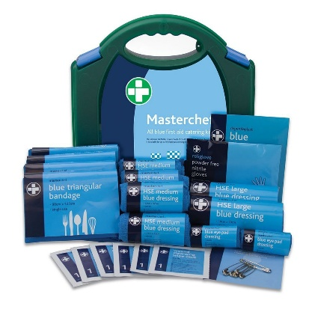 | Catering First Aid Kit  - 1 Guidance Leaflet  - 6 Cleansing Wipes  - 2 Eye Pad Dressings  - 1 Gloves (pairs)  - 2 HSE Large Dressings 18cm  - 6 HSE Medium Dressings 12cm  - 20 Plasters Blue Assorted  - 6 Safety Pins  - 4 Triangular Bandages

Disposable gloves should be vinyl, nitrile or powder free, low protein latex and CE marked.
Blunt ended stainless steel scissors (minimum length 12.7 cm) may also be useful to cut clothing away.

